PRACTICAL NO:-7
Layer 2 VLAN Security.
Creating vlan:
We cannot create vlan1 since it is already present.
So lets start with vlan creation on switches:
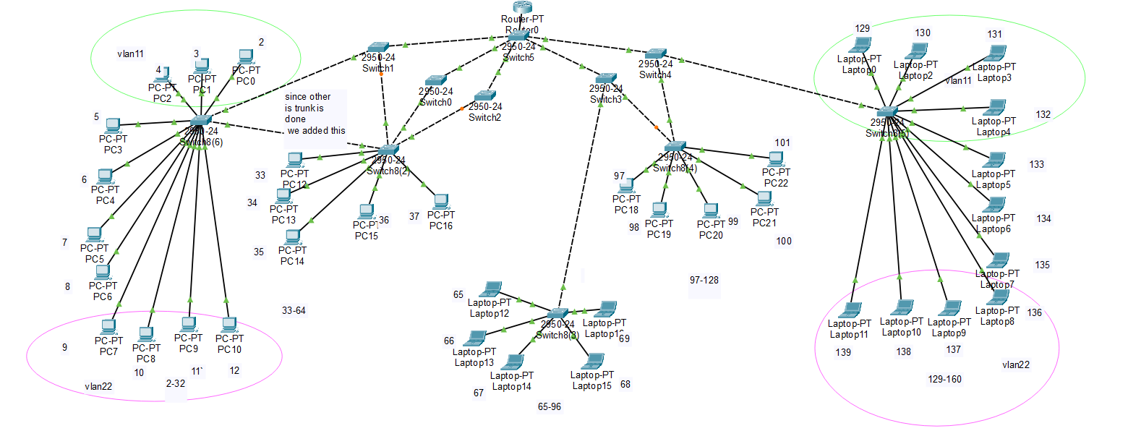
Switch(config)#vlan 11
Switch(config-vlan)#name vlan11
Switch(config-vlan)#vlan 2
Switch(config-vlan)#name vlan2
Switch(config-vlan)#vlan 3
Switch(config-vlan)#name vlan3
Switch(config-vlan)#vlan 4
Switch(config-vlan)#name vlan4
Switch(config-vlan)#vlan 5
Switch(config-vlan)#name vlan5
Switch(config-vlan)#exit
Switch(config)#
Now we will assign interfaces to them:
Switch(config)#interface fa0/1
Switch(config-if)#switchport access vlan 11
Switch(config-if)#interface fa0/2
Switch(config-if)#switchport access vlan 2
Switch(config-if)#interface fa0/3
Switch(config-if)#switchport access vlan 3
Switch(config-if)#interface fa0/4
Switch(config-if)#switchport access vlan 4
Switch(config-if)#interface fa0/5
Switch(config-if)#switchport access vlan 5
If you connect them to switch to switch you might also get warnings.

Here we first defined on connected switch that:
Switch(config)# vlan 11
Switch(config-vlan)# name vlan11
Same way another vlan that is
Switch(config)# vlan 22
Switch(config-vlan)# name vlan22
Now same we will add to all switch through which the vlan is going to be connected.
Now to which the Interface the device is connected we will execute below command to connect to that interface:
Switch(config)# interface fa0/1
Switch(config-if)# switchport mode access
Switch(config-if)# switchport access vlan 11
Same for other pcs connected to interface of switch.

Now between the interface we should trunk between these interfaces through which it will communicate between other switches
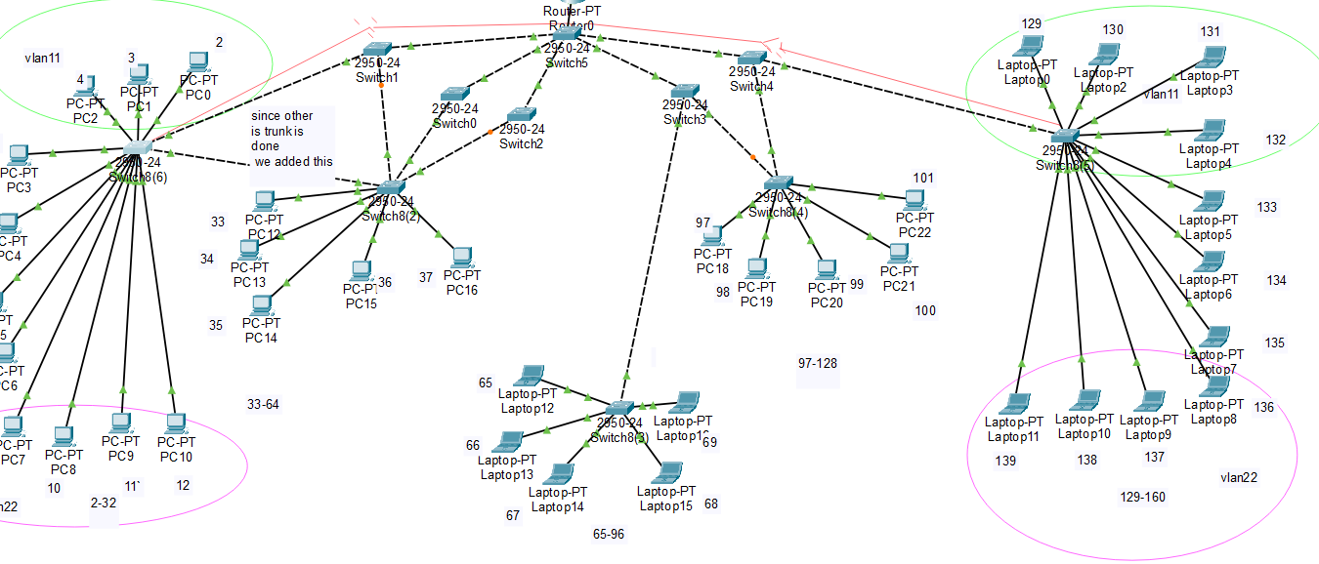

Here as we defined in red line that interface should have trunk to communicate and VLAN IDs must exist on all switches, and trunks only carry VLAN-tagged traffic between switches.
The commands are:
Switch# configure terminal
Switch(config)# interface fa0/1
It is required to interface through which it communicate.
Switch(config-if)# switchport mode trunk
Switch(config-if)# switchport trunk allowed vlan 11,22
Switch(config-if)# end
A trunk port can still forward traffic, but it expects VLAN-tagged frames. End devices (PCs) should not be connected to trunk ports because they send untagged traffic

Diagram:
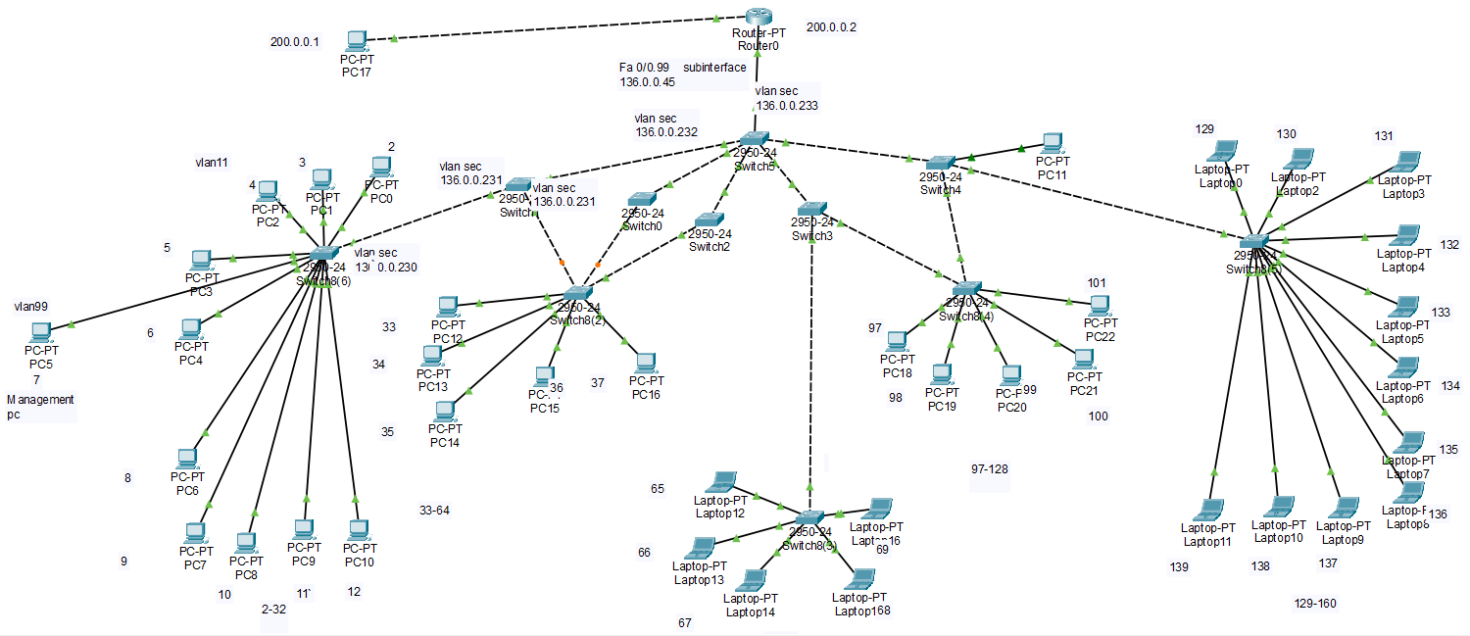
Layer 2 VLAN Security:
1)shutdown unused interfaces:
First we will shutdown all the interfaces which are not been used.
Commands:
Switch(config)#interface FastEthernet0/13
Switch(config-if)#shutdown

%LINK-5-CHANGED: Interface FastEthernet0/13, changed state to administratively down

Or once we can directly can close all interfaces at once:
Switch(config)#interface range Fa0/13-24
Switch(config-if-range)#shutdown
%LINK-5-CHANGED: Interface FastEthernet0/16, changed state to administratively down

%LINK-5-CHANGED: Interface FastEthernet0/17, changed state to administratively down
…

2)Adding separate VLAN:
Added one more pc consists of vlan99 that is not previously there in network. So that it will not be accessible from other devices,thats why we added in another vlan.
Added to all path routers the data in vlan:
Switch(vlan)#vlan 99 name vlan99
VLAN 99 modified:
Name: vlan99
Switch(vlan)#
Now add that vlan99 to interface.

Switch(config)#interface FastEthernet0/7
Switch(config-if)#switchport access vlan 99

Now added the interfaces the ip through which data will transfer.Also add this new vlan to all pcs through which these are being transfer the packets.
Now for communication we will add ips to it.

3) Switch nonegotiate
Here we will use this interface which connects to router to switch. We will use this interface with nonegotiable.
Where to Add Router nonegotiate in a Network Topology (and Why).
What nonegotiate is REALLY for
- It disables DTP (Dynamic Trunking Protocol)
- Prevents automatic trunk formation
- Protects against rogue trunk attacks
- Reduces Layer-2 attack surface
So we add it only where trunking must be explicit and fixed.
Switch ↔ Router Links (MOST IMPORTANT)
Where
- Router-on-a-stick links
- Any switch interface directly connected to a router
Why
- Routers do not support DTP
- No need for negotiation
- Prevents accidental or malicious trunk changes
We add switchport nonegotiate on the switch interface that connects to the router so that no DTP packets are sent or accepted on that link. This prevents any DTP-based manipulation from the external network side.
What are DTP packets?
DTP (Dynamic Trunking Protocol) is a Cisco proprietary Layer-2 protocol used by switches to:
- Automatically decide whether a link should be:
  - Access
  - Trunk
- Exchange this decision using DTP packets
DTP packets are control-plane frames, not user data.
When switchport nonegotiate is enabled, the switch neither sends nor accepts DTP packets on that interface. As a result, the port does not dynamically change its operational mode and remains statically configured as access or trunk.
Now we will apply it to below connection from router to switch so that we will not receive DTP packets from there:
(we can also apply to switch to switch since we can also receive DTP packets from switches as well.)
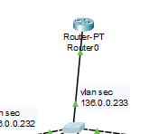
Commands:
Switch(config)#interface Fa0/6
Switch(config-if)#switchport mode trunk
Switch(config-if)#switchport nonegotiate

4) encapsulation dot1Q
encapsulation dot1q is a method that adds a VLAN tag to data packets so devices know which VLAN the packet belongs to.
It puts a VLAN number label on the packet.
If we not added encapsulation then the router will NOT understand VLAN traffic at all.

***Now we will Enable the Management PC to Access Router R1.***
Now we will enabled encapsulation dot1q on router:
Step 1: Go to the physical interface (NO encapsulation here)
It is also required to remove the ip if there is ip to this main interface.
Because
You already have an IP address configured on the physical interface FastEthernet0/0, and now you are trying to assign another IP from the SAME network on the subinterface it is not allowed.

Router(config)# interface FastEthernet0/0
Router(config-if)# no ip address

Router(config-if)# no shutdown
Step 2: Create a subinterface
Router(config)# interface FastEthernet0/0.99
Step 3: Apply dot1q encapsulation
Router(config-subif)# encapsulation dot1q 99
Step 4: Assign IP address
Router(config-subif)# ip address 136.0.0.45 255.255.255.0

Commands:

Now we will add the new vlan to all the interfaces through which the packet will transfer from.
Here it is vlan 99.
We will add to all the switches in between here:
Also we will add the subinterface as the default gateway 136.0.0.45 so that it can communicate outside network as well.

Here subinterfaces :
A router port can understand only ONE network by default.
A switch can send MANY VLANs on ONE cable.
So we need a trick to make one router port handle many VLANs.
That trick = subinterfaces.

Now we will able to access it through any external network as below:
Management pc to the router:
